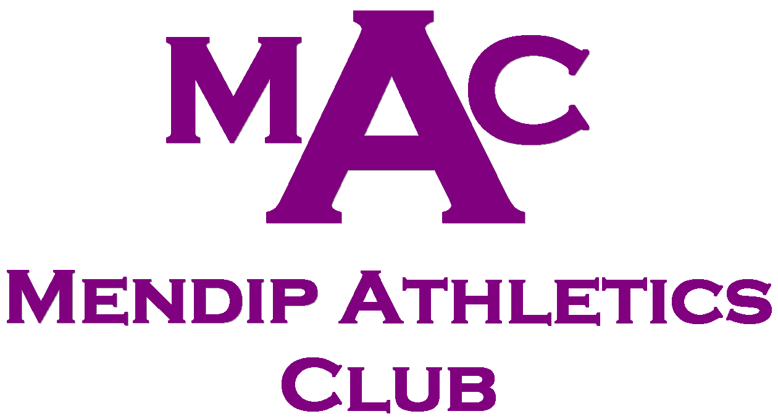
South West Athletics League 2019

In order to assess numbers, allocate events and select teams could all MAC athletes please complete and return the attached form. I will then contact everyone approximately two weeks before each match to check on the athlete’s availability prior to team selection.

The South West Athletics League (SWAL) is our primary track and field competition throughout the summer months. It gives our athletes the opportunity to put all the hard work and training to the test in a competitive but friendly atmosphere.

Many members will have been to matches in previous seasons and know what to expect. For those who haven’t been before I have detailed some information below.

The South West Athletics League consists of eleven athletic clubs from across Somerset, Dorset, Devon and Cornwall.

There are four league matches throughout the season, all held at Exeter Arena, Summer Lane, Exeter, EX4 8NT.

Dates & Times for Summer 2019

Sunday 2nd June
Sunday 7th July
Sunday 4th August
Sunday 1st September

Events start at 10:30am and are generally finished by 6pm.
All age groups are covered from U13 (school year 6) to seniors.

Entries & Rules

Each athlete may enter three events plus a relay at each match. The club are limited to four athletes per event at U13, three athletes per event at U15 and two athletes per event at U17 upwards. Teams will be selected for each age group based upon previous times / distances, however, we will ensure that all athletes who are available will compete at a number of events.

The more events that each athlete is prepared to compete at the more likely it is that they will get selected for their maximum number of events and, additionally, the more points the club will receive. Please bear this in mind when filling out the registration form.

There are two programmes ‘A and B’ that have slightly different events. Each programme is used twice during the four match season. This is to allow opportunity for a wide range of events to be covered throughout the season. Copies of the draft A and B programmes are attached.

Points & Scoring

Points are scored by the highest two finishing athletes for each club. The athlete in first place collects 22 points, second place 21 points, third place 20 points and so on. Athletes finishing outside the first two from each club do not score. League tables are produced for each age group and gender as well as the overall team competition.

Social

More importantly than the club points scored, SWAL gives all of our athletes the chance to compete against other clubs in a competitive but friendly environment. Many athletes make friends with athletes from other clubs and as they continue their athletics will often meet the same people away from MAC at schools events, County Championships, cross country meetings and parkruns.

Many of our athletes have achieved personal bests at these events (60+ MAC PB’s recorded at SWAL in 2018) and all results are properly recorded and registered on ‘Power of 10’.

Officiating

A condition of entry to this league is that each club has to provide two track officials and five field officials at each meeting. Clubs are awarded further points for providing the requisite number of officials. Parents / carers are always required and welcome to assist on the day. You may also wish to contact our lead official, Andy Rumley, who can arrange official’s courses should you ‘get the bug’.

In order to assess numbers of available athletes and start team selection we ask that all members fill out the attached form and return it by 12th May to:

jon-chivers@tiscali.co.uk.

